**LUKE SKYWALKER**

ABOUT ME:

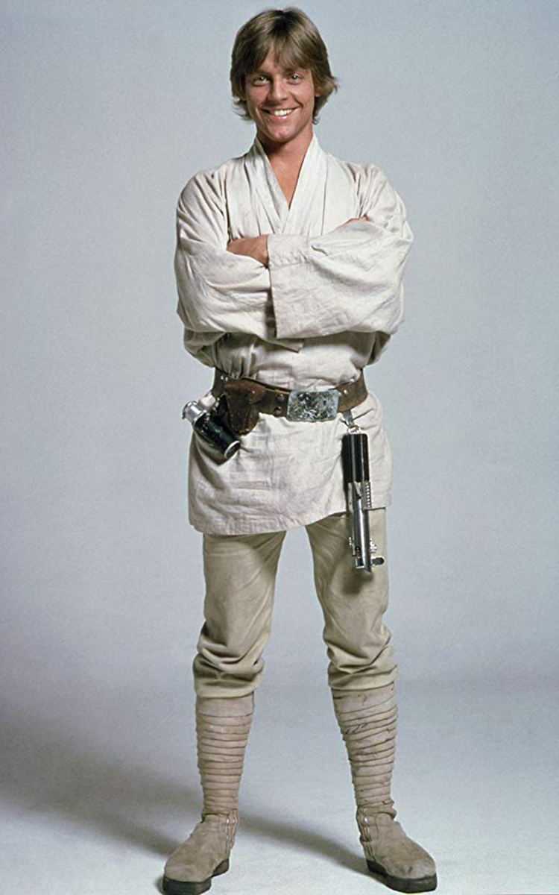

¡HOLA! I am very excited to be part of your class this year, but also a little nervous. I’m excited about middle school. I’ve had a fun summer though a little boring. I like working with my hands, cooking and making things out of paper, Legos or whatever. I was diagnosed with “Fun ADHD” (I just want to have fun all the time). Last year was hard at times but I’m hoping to have a better year this year. My family and I are working hard to learn strategies that can help me with my distraction and impulsivity. My goal this year is to do my best and feel better about school which is sometimes overwhelming for me!

MY STRENGTHS

STRATEGIES THAT HELP ME

* Visual learner
* Always happy
* Social
* Kind
* Bilingual
* Like nature

Message from Mom and dad:

* Sit in front
* Seeing examples
* Watch videos
* Have class notes in advance
* Have some bathroom breaks
* Divide the exam in parts
* Break down long instructions

We are Darth Vader and Padme Amidala, Luke’s parents, and we are very thankful you will be his teacher this year. We are originally from Tatooine but Luke was born in the asteroid of Polis Massa. At times the school system is confusing, and even though I’ve tried to learn English and do a pretty good job at this point, sometimes I still struggle with some words. We are very proud of Luke because he’s smart, loving, a fighter and fun to be with. We are working to understand how to best support Luke and want to work with you this year in whatever way you think is helpful.

Contact: 919-146-0000 call/text at any time